Summer PEIMS for Business

Only two items need the attention of Business staff for Summer PEIMS: Unique IDs and PK teacher specializations.
- Ensure all applicable staff have a Unique ID.
  - Regular Subs do not need a Unique ID, but long-term subs that serve as the teacher of record will. These subs will be filling a position for a staff member who quit or passed away before the end of school, requiring a long-term sub to finish the year. Long-term subs do not normally pull during the Unique ID extract, so they must be changed temporarily to a Pay Type 3. From Maintenance>Staff Job/Pay Data>Employment Info Tab change the employment type to Active Professional. From Maintenance > Staff Job/Pay Data > Job Info tab, retrieve the sub. Change the Pay Type from Type 4 to Pay Type 3. A Pay Rate will also be required. (We recommend printing or saving a copy of the original screens before making changes so you can reset them when finished.)

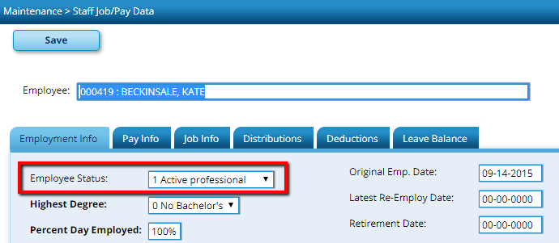

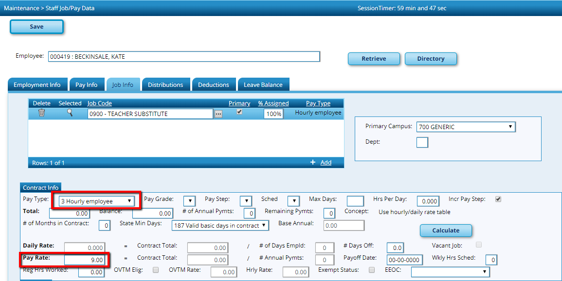

The Unique ID Extract can be completed and the long-term sub should be included. Once the Unique ID is assigned and entered into TxEIS, the long-term sub can be changed back to the original settings of Pay Type 4 and no set Pay Rate.
  - From Utilities > Texas Unique Staff ID Interface, enter the school year and Execute.

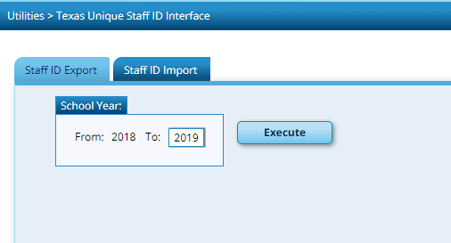

A preview will be displayed listing all employees without a Unique ID. Process to obtain the file to upload at TEA’s website for TSDS Unique IDs. (TEAL/TSDS Access required).

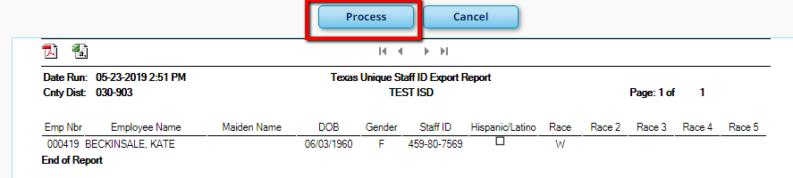

Note: A separate document with detailed instructions for obtaining Unique IDs is available on our website or you may call a TxEIS Business Consultant for assistance.

- PK teachers must be certified and also have one of the following additional qualifications:

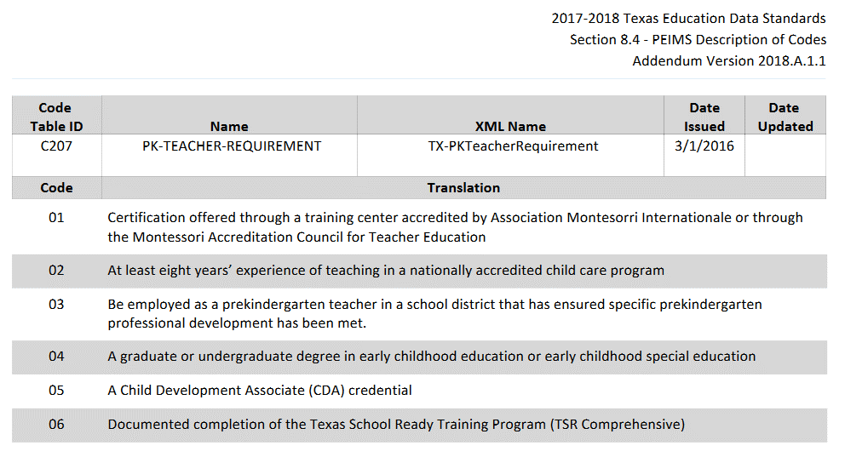
In TxEIS, first verify your table includes the necessary info. From Tables > Credentials > Teaching Specialization tab, check the code for Early Childhood Education. You may have more than 1. For each of these, you must assign a PEIMS PK Teacher Requirement that has been met. Save any changes.

The next step is to assign those specializations to all PK teachers. From Maintenance > Staff Demo > Credentials tab, retrieve a PK teacher. In the Certification Area, enter the data. At a minimum, you must have a Teaching Specialization. Other data may apply.

